**How to Register/Log in**

* Open your Internet Browser (Internet Explorer, Firefox, etc). Click on the following link, or copy and paste it into the web browser:

https://login.myschoolbuilding.com/msb?acctNum=903810048&productID=FSD

* If you are a returning user, enter your **Email Address** and **Password**. Click **Sign In**.
* If you have forgotten your password, click the **Forgot Password?** Link and enter your email address. We’ll send you instructions for resetting your password.

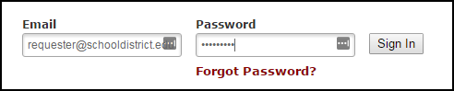

* If you are submitting your first request, you must enter registration information first. Click on the down arrow () next to Never Submitted a Request? Register Here! to expand the registration form. *\*Note: Your registration will be complete after you submit your first work request.*
  + 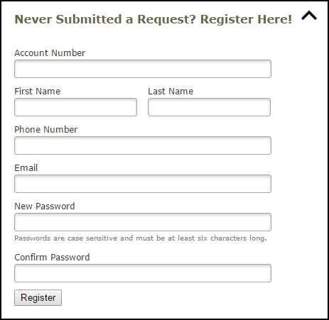Enter the **Account Number** provided by your Administrator.
  + Enter your **First** and **Last Name**, as well as your **Phone Number** and **Email Address**.
  + Type the **Password** you would like to use to log into your SchoolDude account and confirm it. The password you choose must be 6 characters long.
  + Click **Register** to go to the work order request form.

**The Dude Says:**To create a shortcut to your desktop, find a blank area on this screen and right click on your mouse. You will have the option to create a shortcut or add to your favorites. Creating a shortcut will add an icon to your desktop. You can double click it the next time you want to sign in.

**The Dude Says:**If you need to check the calendar before submitting your requests, click on the link below once you are logged in. It will take you right to the Month View calendar. The calendar may not display any events at first. Select from the **Location** drop down menu then click **Refresh Calendar**. You can also filter your calendar view according to room, organization, etc.

https://www.myschoolbuilding.com/myschoolbuilding/mydtfs_calendar.asp?nmonth=&nyear=&LocID=&buildingid=&RoomID=&AreaID=&eventstatus=&FirmID=

calendar.asp?nmonth=&nyear=&LocID=&buildingid=&RoomID=&AreaID=&eventstatus=&FirmID=

**How to Submit a Request**

* Click on the **Schedule Request** tab if you do not see the screen below. Select one of the three schedule types:
  + **Normal Schedule**: Most commonly used and the one covered in this guide (Up to 20 event dates can be selected). This schedule is used when all event dates will share the same time and room(s).
  + **Recurring Schedule**: (Up to 100 events can be added). This schedule is used for events that follow a pattern (Every Monday and Wednesday for a semester or the 3rd Friday of the Month for the entire year). All event dates will share the same time and room(s). *Note: For specific instructions on entering a Recurring schedule, click on the **Help** link at the top right of the screen and then click on **FSD Requester Online Help**.
  + **Irregular Schedule**: (Up to 20 events can be selected). This schedule type can be used when each event will take place in a different room and/or a different time slot than the other event dates within the schedule. For example: The Boy Scouts will use the Gym on January 1st from 9am to noon and their next meeting will take place on January 31st in Room 200 from 1pm to 2pm. *Note: For specific instructions on entering an Irregular schedule, click on the **Help** link at the top right of the screen and then click on **FSD Requester Online Help**.

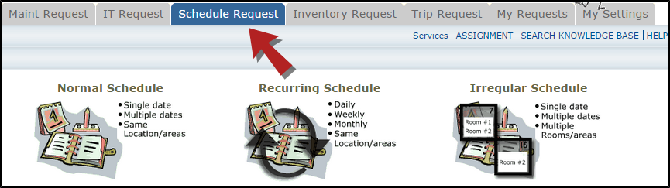

* When entering a schedule, any field with a red checkbox beside it is a required field. The system will not save your request if the information is not filled out.
  + Enter the **Event Title**.
  + Click on the drop down menus beside **Location** and **Rooms** to select the spaces that are needed.
  + Choose your event dates by clicking on the date in the calendar box to the right. You can click on the arrows in the calendar box to select a different month.
  + Enter the **Start Time** and **End Time** and make sure that you are selecting AM or PM for the correct time of day. You may select a **Setup Begin Time** and **Breakdown End Time** if needed for this event.
  + Click on the **Check Availability** button to verify you are not double booking a room.

*\*Note: The boxes beside* ***Duration*** *and* ***Spans*** *(shown below the Setup/Breakdown time) typically will not need to be changed. Spans over should be left as 1 day unless you are requesting an overnight event. The duration automatically calculates according to the start and end time that you enter.*

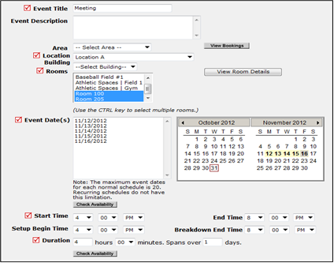

* Enter any **Additional Information**, **Organization Information**, **Insurance Information**, **Setup Requirements**, and **Rental Requests** that may appear on the form. Remember to fill in all required fields marked with a red checkbox.
* Attach a file to your schedule request by clicking the **Add New File** link. Browse your computer for the file and select it. You can also enter a **File Description**. Click **Submit**. *Note: There is no limit to the number of files that can be attached, however the total size of all uploaded files on the schedule must be less than 5MB.
* At the bottom of the page you will be prompted to enter the **Submittal Password** of (***Insert Submittal Password Here***). Click **Save** to submit your request.

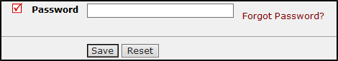

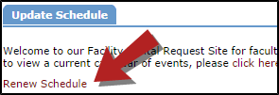*\*Note: If you have multiple schedule requests to enter at one time, you can use the Renew feature to save you time. Once you have submitted the first request, scroll to the top of the screen and click on* ***Renew Schedule****. This feature acts as copy button and will copy all the information, except for event dates, from the schedule that you just submitted into a new schedule request form. Because it is a new schedule, you will be able to update any of the necessary fields and add the new event dates.*

**My Request Tab**

You can view any requests that you have entered into the system by clicking on the **My Requests** tab. Hover your mouse over the **Shortcuts** link and click on **My Schedule Requests**. You will be able to see when your request has been approved, declined, etc. You are also able to print out a listing of your requests to PDF or Excel by using the icons at the bottom of the lists.

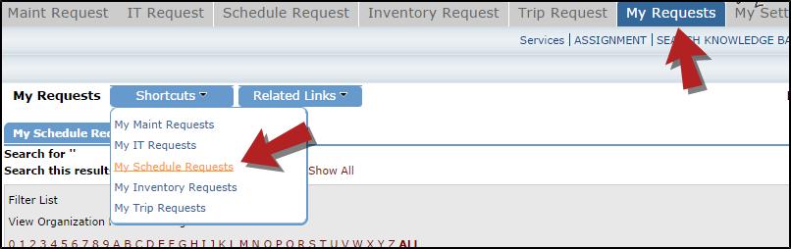

**How to View the Calendar**

* You can access the Month View of the event calendar directly by following this link: https://www.myschoolbuilding.com/myschoolbuilding/mydtfs_calendar.asp?nmonth=&nyear=&LocID=&buildingid=&RoomID=&AreaID=&eventstatus=&FirmID=

**OR**

* You can also view the calendar by clicking on the **My Requests** tab.
  + Hover your mouse over the **Shortcuts** menu and click on **My Schedule Requests**.
  + Hover your mouse over **Related Links** (next to the Shortcuts menu) then click on **Month Calendar**, **Day Calendar**, or **Week Calendar**.

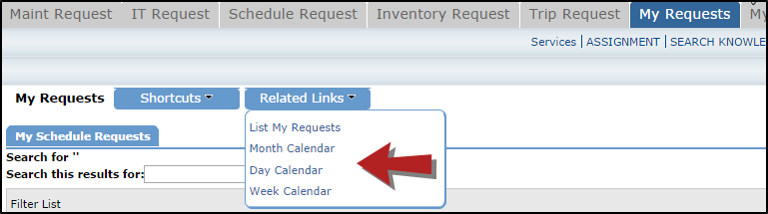

* When accessing the month calendar, for example, the default view will be on the current month/year. You can change either of these by using the **Select Month/Year** drop downs. *Note: The calendar may not display any events at first. Select from the Location drop down menu then click **Refresh Calendar**. You can also filter your calendar view according to room, organization, etc.

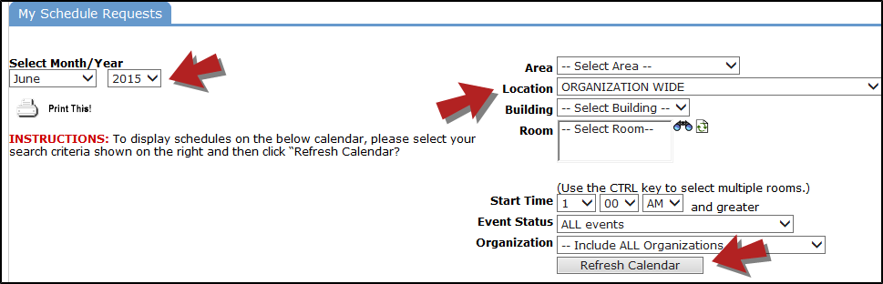

* The items that you will see on the calendar are the events titles. If you would like more information about a particular event, simply click on the title to view the details. There is a Legend under the calendar which indicates what the dots and symbols to the left of the event title represent.

